# On 7th we connected and started discussing from

# Day 1 (08/06/2022)

* Stores all documents (data) in one location and disseminates them via search.
* According to ISO 15489 standard used for the framework, we should save one legal document at a location that defines how long we need to retain the document or keep it. (It depends on business needs)

E.g.:

* + - We will have receipts for shopping and any other CC transactions till we receive a credit card bill. (for checking discrepancy)
    - After the FY audit is completed, the company will maintain records for a specific period.

That time is called retention.

* Every municipality and province will follow these retention policies.
* On-site storage (office folder) > Off-site storage (maybe a storage box outside of the office folder).
* If they need the document in between, they may recall it.
* Govt. organizations will have a .exe file (code is mapped from server to sub-systems) and they execute that file.
* Administration > Record Attributes > EDIT RECORD SERIES ATTRIBUTES (here you’ll find different services and functions) while delivering we will give blank forms they need to fill out.

For example, in HR operations, we will have several functions such as Resource Management, Career Opportunities, and so on.

* File > New, then select the subject.

You can see Record Series Attributes on the right side (which were there at the backend given by administration)

* Administration > Staff Details > Employee Details, you can see all the roles and users. (As you are a super user you can see the total list.)

# Day 2 (09/06/2022)

* Explained a few options under Administration
  + - Access Disposition Period – any retention from the closing of the request
    - Access Request Costs – cost for each output like color or black & white.
    - Add Tax -
    - Audit Trial (not covered)
    - Cabinet Location
    - Controlled Vocabulary
      * DIR
      * Document Kind
      * Document Types
      * Format Media – we can add media type
      * Legend – defining period for
      * Status
      * 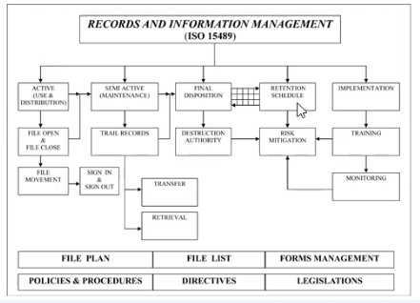Subjects
* Active > semi-active (in the trail we can recall the record).
* Present year requests will be only available.
* System saves time and improves productivity.

What needs to be added for different data types will be given later. (data kinds….)

# Day 3 (10/06/2022)

* Connected with Prakash asked a few queries, and received some inputs.

# Day 4 (11/06/2022)

* Checked some record management tools, referred day 2 video, and made some points.

# Day 5 (12/06/2022)

* Clarified a few questions and explained a few options under Access Request.
  + - Routine Access Request > Access Request
      * Look in for the file by searching and whatever the public documents available are given highlighted and the remaining will be not highlighted (not given). Hard copy also non-downloadable.
      * Give all access information.

# Day 6 (13/06/2022)

* Checked some references, referred day 5 video, and made some points.

# Day 7 (14/06/2022)

* Explained a few options under Administration
  + - Help – under this, we can add help support doc links or contact us sort of links.
    - Institutions – On the top left we can see the Institution, we can modify the name as per our organization’s requirement.
    - Price Master - As per regulation 823, we fix the price for the work (for resources) in Price Master.
    - Record Attributes
      * Edit Record Series Attributes
      * Functions – To add a function name
      * Record Series – To add Record Series Name for a Subject
      * Record Series Attributes
    - Shelving Information
    - Storage Locations
    - Transfer Label Print

# Day 8 (15/06/2022)

* Explained a few options under Administration
  + - Staff Details
      * Departments
      * Designations
      * Employee Details
    - Template Date - here we give Meta data Info (Extra Information sort of tags)
    - User Roles

# Day 9 (16/06/2022)

# Day 8 (16-Jun-22)